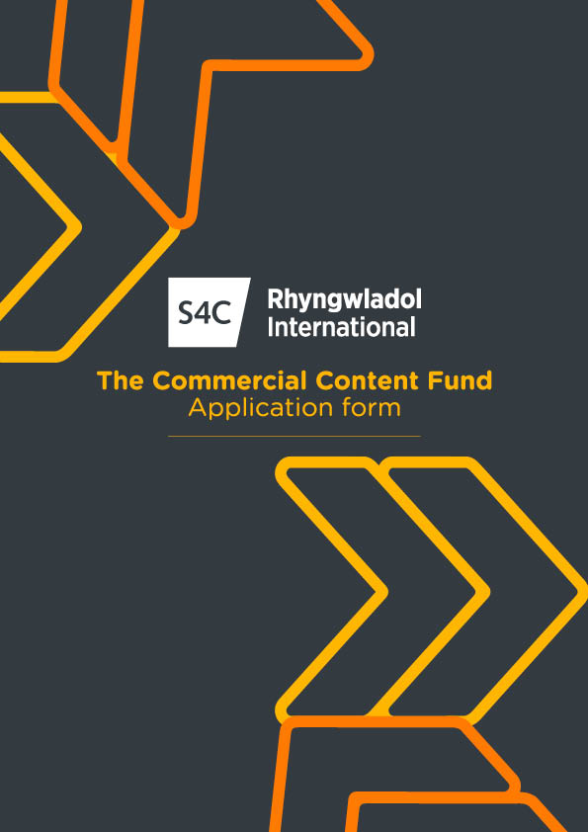

S4C International/Rhyngwladol Commercial Content Fund
Application Form
Applicant details
Name
Address
Contact details
Company size and key programme titles.
Please attach 2 prior years’ accounts and management accounts for the current year.
Project Description
Title
Genre
Duration /episodes
Production Company
S4C Commissioner
Synopsis

Finance/ Investment details
Investment Opportunity Summary
Investment Category (Development/ Production/ Tax Credit)
Proposed Investment Amount
Intended Use of Investment
Standard S4C Licence Fee
(please explain why the investment ask is above the usual S4C licence fee and how the additional funds will add value to the production - in terms of commercial potential as well as other factors: scale; creative impact; up-skilling Welsh language sector; international trade)
Total Production Budget/ Development Cost
(full details to be attached)
Production schedule (including, where relevant, timeline for investment to be cashflowed)
Production Funding Plan / partners (please include details of any funding agreements or arrangements with other parties including: S4C, other broadcasters, funders, grants, distributors, private equity, Svods, brands etc.)
Distribution/ sales arrangements
(details of distributor/sales agent, together with detailed sales projections and marketing plan to be attached)

Commercial
Commercialisation Plan (please evidence commercial viability - distribution deal, commission, broadcaster etc.)
Other Considerations. Please explain:
How will the investment benefit the economy of Wales?
How will this investment support the development of sector commercial skills?
How will this investment develop the recognition and reputation of S4C content?
Key Talent
Key individuals who will be involved in the Project and relevant experience:
Who is responsible for execution/editorial and delivery standards in line with budget, genre, industry, and platform expectations?
Rights & Deal Terms
Key Terms
Please attach a recoupment proposal (please note that this will be negotiated after completing our own due diligence on sales figures)
Key Criteria
Is a this a Priority genre or high impact commission? (please give details)

On screen credit for Commercial Content Fund investment?
75% of production costs spent in Wales?
75% of the production team based in Wales?
Approvals to Date

I confirm that all information provided on this application and in any material submitted in support of it, is complete, truthful and accurate.

I confirm I have read and understood the Fund’s Guidelines and have the authority to make this application.

Name:

Signature:

Position:

Date:

Submission of Application

The completed application form should be submitted ONLINE via S4C website: https://www.s4c.cymru/en/commercial/page/57485/s4c-international-the-commercial-content-fund/

OR by e-mail to Claire.urquhart@s4c.cymru You should clearly mark “Commercial Content Fund Application Form” in the subject panel of the e-mail.

Please note – we will aim to acknowledge you application within 20 days. A funding decision may take longer than 12 weeks and is subject to a fully completed application and further information on request.

Contact Language
Please tell us which language you'd like us to use to contact you about this application:

- Cymraeg
- English

Clarification of Application

S4C Rhyngwladol Cyf (‘S4C International’) may require you to provide further information and/or clarification of any matters contained in your application. S4C International reserves the right to hold discussions with the applicant where further information or clarification is needed.

S4C International reserves the right to disqualify an application from this process at any time if any information provided on the Application Form is incomplete, inaccurate, or misleading in any way.

Request for Further Information

If you need to contact S4C International regarding this process, including making any request for further information and/or guidance on completing an application, this should be done by sending an e-mail to: Claire.urquhart@s4c.cymru

Data Protection

By submitting an application, the applicant authorises S4C International to process all personal information provided as part of the application in accordance with the Data Protection Act 1998 and confirms that it has obtained all necessary third-party consents to enable S4C International to do so.

Conflict of Interests
The applicant must provide details if it is envisaged that there may be a conflict of interests between individuals involved in the application and S4C International or S4C staff or officers. This is to enable S4C Rhyngwladol to ensure that it assigns staff or officers to this process who have no personal relationship with the applicant.

Freedom of Information

The Freedom of Information (“FOI”) Act 2000 applies to S4C but not to S4C International. If S4C possesses any information from or relating to S4C International, then the FOI Act applies to that information. If the applicant considers that any information provided by it to S4C International as a result of this process is of a confidential or commercially sensitive nature, the applicant should indicate this explicitly and the reasons for considering such information to be confidential or sensitive information. If relevant, S4C International and/or S4C will consider this when deciding whether to release information in response to FOI requests. However, the applicant must accept that S4C International and/or S4C will release such information if it has legal advice that it must do so in order to comply with the FOI Act. S4C International and/or S4C retain the right, in their absolute discretion, to decide whether any particular information is exempt from disclosure.

Application Costs

The applicant is responsible for the costs and expenses which are payable in connection with this process.
Can I get access support with my application?
For applicants with access requirements, for example individuals who are D/deaf, hard-of-hearing, Disabled or neurodiverse people, and people with sight loss, further support is also available to complete an application. For example, we can cover the costs of a BSL interpreter for a meeting with us prior to making an application, or scribing support for dyslexic applicants, or agree alternative formats for applying such as a short video or slide deck. Please contact us to discuss how we can help in advance of making an application.

