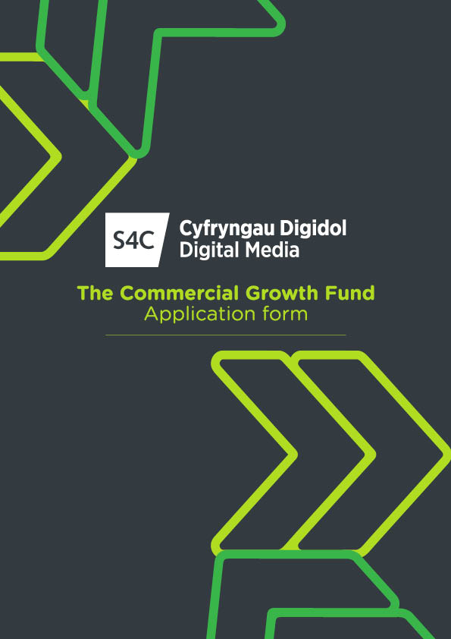

The Commercial Growth Fund Expression of Interest Form

Applicant details
Company Information
Full Trading Name: _______________________________________________
Date of Incorporation : _______________________________________________
Main point of contact and title: _______________________________________________
Shareholders and % of company owned by each shareholder:
___________________________________________________________________________
HQ Address: _______________________________________________
Phone: ________________________________________________
Email: _______________________________________________
Company Description
Genre: __________________________________
Company key programme titles for S4C. (please include commissioner, no of eps, duration and year):________________________________________________________________
__________________________________________________________________________________
Company key programme titles for other broadcasters (please include broadcaster, no of eps, duration and year):
____________________________________________________________________________________________________________________________________________________________________
Finance/ Investment details
Turnover and Net Profit in 2022: _________________________________________
Anticipated Turnover and Net Profit in 2023: _________________________________________
Proposed Investment Amount (if known): ____________________________________________
Intended Use of Investment (in brief): _______________________________________________

Eligibility:

Please outline activity based in Wales: ____________________________________

I confirm that all information provided on this application and in any material submitted in support of it, is complete, truthful, and accurate.

Name:

Signature:

Position:

Date:

Submission of Application

The completed application form should be submitted by e-mail to laura.franses@s4c.cymru You should clearly mark “Commercial Growth Fund Application Form” in the subject panel of the e-mail.

Please note – If the application is successful, an invitation to a follow up call/meeting will be made within 6 weeks. Should your application progress following this, you will be asked to provide extensive legal and financial documentation relating to the company and be assessed against the Growth Fund criteria.

ABOUT THE S4C COMMERCIAL GROWTH FUND
What is the S4C Commercial Growth Fund?
The S4C Growth Fund is a new investment fund that is being established within S4C’s Digital Media Arm. The Fund will invest in businesses that are closely aligned with S4C’s long term strategic aims and that can demonstrate the opportunity and potential for growth. The fund will act as a catalyst for that growth and play a prominent role in harnessing the significant potential of the creative industries in Wales.

Why is the Growth Fund being established?
In 2022, S4C agreed a new 5-year funding settlement with government. Alongside the funding settlement S4C implemented a new 5-year strategy to deliver greater value from its resources – including through S4C’s commercial operations. The aim of the strategy is to bring creative and economic value to S4C’s audience in Wales and support the long-term development of S4C.

The Growth Fund is a key component and has three principal objectives:
i) To deliver a financial return on its investment.
ii) To support businesses that can deliver to S4C’s future strategic needs
iii) To support the development and growth of the creative economy in Wales, including through the creation of new jobs and skills.

In delivering its objectives the Growth Fund will also provide a new source of growth capital for SMEs in Wales.

What kind of businesses will the Growth Fund invest in?
The Growth Fund will consider investing in any business based in Wales that is aligned to S4C’s long term strategic needs. The Fund will consider investments in production and content creation companies alongside other types of business, eg digital development or deepening connection with audiences. The Fund also expects to invest in businesses at different life stages: from start-ups to established businesses that need growth investment to reach the next level. Returns from these investments will be apportioned between further investment within S4C Commercial and the Public Service Fund.

What is the business model of the Growth Fund?
The Growth Fund will take shares in the business it invests in and may provide part of its funding as a loan. As a growth investor the Fund does not expect to hold shares for the long term: its intention is to realise the growth in the value of invested businesses by selling its shares and exiting the business - typically between 3 and 6 years after the investment is made.

What are the benefits of Growth Fund Investment?
The Growth Fund is designed to help businesses reach their growth potential. It does this in a number of ways but in particular it provides capital that its invested businesses can use to secure the resources they need to grow.
SDML accepts no responsibility for any shortcomings in the delivery system or for any lost, delayed, or defective application. You are responsible for ensuring that your application (and any attachments) is prepared and submitted.

___________________________________________________________________________________

Clarification of Application

SDML may require you to provide further information and/or clarification of any matters contained in your application. SDML reserves the right to hold discussions with the applicant where further information or clarification is needed.

SDML reserves the right to disqualify an application from this process at any time if any information provided on the Application Form is incomplete, inaccurate, or misleading in any way.

Data Protection

By submitting an application, the applicant authorises SDML to process all personal information provided as part of the application in accordance with the Data Protection Act 1998 and confirms that it has obtained all necessary third-party consents to enable SDML to do so.

Conflict of Interests
The applicant must provide details if it is envisaged that there may be a conflict of interests between individuals involved in the application and SDML staff or officers. This is to enable SDML to ensure that it assigns staff or officers to this process who have no personal relationship with the applicant.

Freedom of Information

The Freedom of Information (“FOI”) Act 2000 applies to S4C but not to SDML. If S4C possesses any information from or relating to SDML, then the FOI Act applies to that information. If the applicant considers that any information provided by it to SDML as a result of this process is of a confidential or commercially sensitive nature, the applicant should indicate this explicitly and the reasons for considering such information to be confidential or sensitive information. If relevant, SDML and/or S4C will consider this when deciding whether to release information in response to FOI requests. However, the applicant must accept that SDML and/or S4C will release such information if it has legal advice that it must do so in order to comply with the FOI Act. SDML and/or S4C retain the right, in their absolute discretion, to decide whether any particular information is exempt from disclosure.

Can I get access support with my application?
For applicants with access requirements, for example individuals who are D/deaf, hard-of-hearing, Disabled or neurodiverse people, and people with sight loss, further support is also available to complete an application. For example, we can cover the costs of a BSL interpreter for a meeting with us prior to making an application, or scribing support for dyslexic applicants, or agree alternative formats for applying such as a short video or slide deck. Please contact us to discuss how we can help in advance of making an application (see Contact Details above).

